Walk 30 Lyonshall
Last walked in December 2017

Description. [Need your speakie as the route may have changed] An 8 km (5 mile) walk across farmland, a short stroll thru woods and along minor roads. Pleasant and interesting surrounding to look at.
Start. Lyonshall Church. Explorer Map 201. Grid 331563.
Directions from Whitecross Roundabout (Turn milometer to zero). Take the A438 to Brecon and after 1.4 miles TR onto the A480 to Stretton Sugwas/Creden Hill. At 2.1 miles you go straight across the roundabout and head towards Kington. At 10.9 miles TL onto the A438, and immediately TR for Kington. At 14.8 miles the road bends R then bends L, and continues on towards Kington. At 15.4 miles TL at a T-junctions and head towards Kington, a little further on (15.5 miles) TR up a narrow drive for Lyonshall church car park.

1. Lyonshall Church and Castle. Face the church and take the path that goes along the R hand side of the church, with the main road being off to your R. Go thru the small wooden gate. (at this point you could bear L and go thru a small metal gate to look around the remains of the Norman castle. Walk round the moat and the back of the keep. The building of the castle started in about 1090, when the Devereux family held it as lords of the manor from Roger de Lacy. In 1406 Owain Glyndur and Welsh raiders damaged both the castle and the church. Bear slightly R to go thru a small metal gate and into a field, bear L and continue along the top of the field to go thru a metal gate onto a tarmac lane. TL, and continue along the tarmac lane that turns into a wide dirt/stony track. Just past the apple tree plantation on your R the dirt/stony track bends around to the R, but you carry straight on along a dirt track that’s to the R edge of a field. The track enters a wood and you go thru a wooden gate and continue on in the same direction for a good distance, (½ km or more) to reach a T junction. TL and walk along a stony track to go thru wooden gates and onto a minor road where you TL. Continue along the road to just before reaching the T junction, you turn ¾ L and walk along an aggregated drive/public footpath.

2. The Heath. At the end of the dirt track/drive you go thru a metal gate into a field F1. After 100m down the R side of the field you TR to cross a stile and walk along a fenced enclosure and thru a metal gate into a field. In the top R hand corner you TR thru a small metal gate, you then TL and go thru a kissing gate into a field. T sharp R, cross the field to cross over a stile into F2. Go just past a wooden hut (L) to TL and pass thru a metal gate and up an enclosed track to reach the main road. Cross the road and thru a k/gate and walk along the L edge of F3. Walk about 100m (almost to the electricity pole) to TL thru a k/gate into F4 and continue along the L field edge/hedge. Follow L field edge/hedge to the bottom L hand corner, TL thru a metal gate into F5. TR, and walk along the R field edge, you are now walking along Offa’s Dyke. Continue along the R edge of this large field to cross over a stile and thru a metal kissing gate onto a tarmac lane that goes to Lynhales Nursing home.

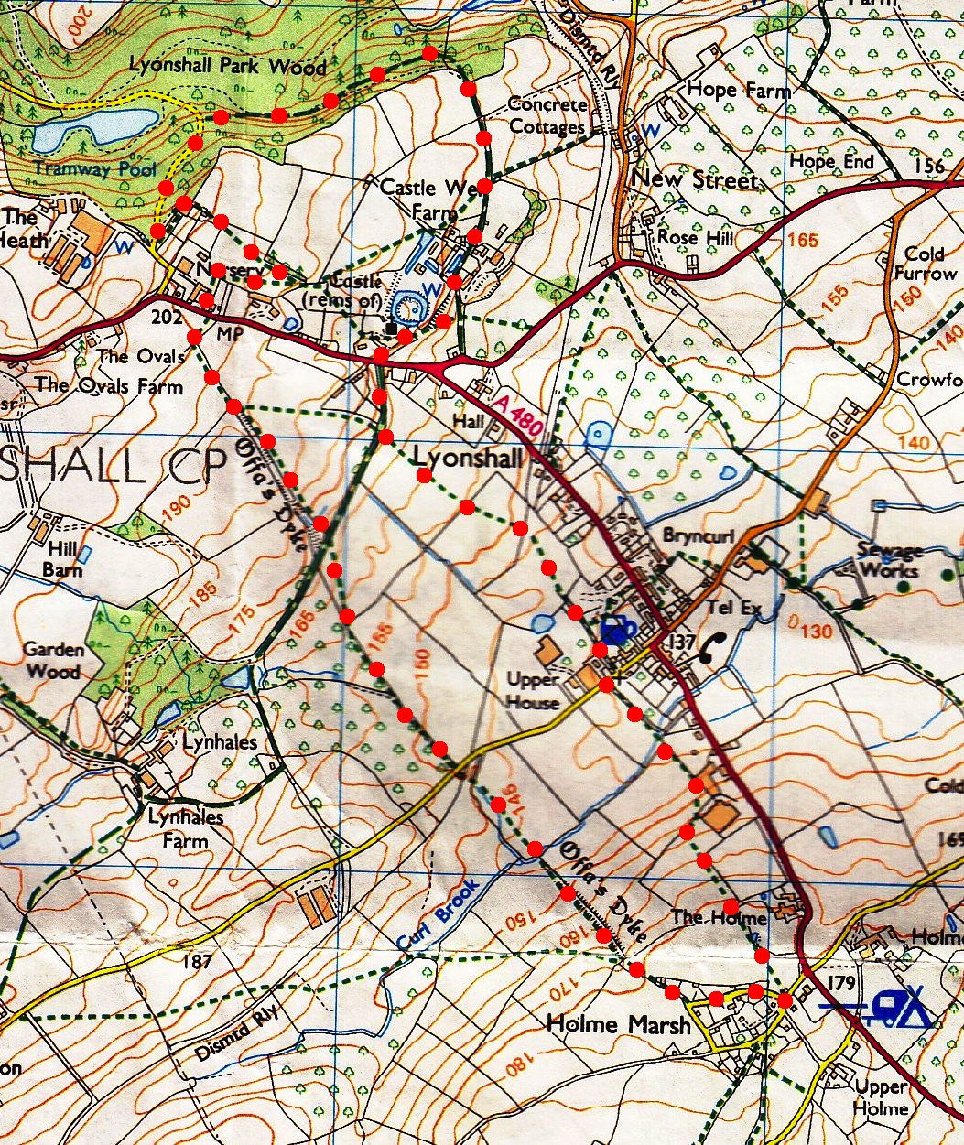
3. Tarmac Lane. TR, walk 30 paces and TL, go thru another kissing gate into F6. TR, follow the R field edge and go thru another kissing gate that’s in the field corner and into an apple orchard. TL, go down L edge and thru the metal gate. Turn sharp R, walk a few paces to reach a track and TL, walk along the track that’s between trees, to reach Bollingham Lane. An archaeological dig by Cardiff University in 2003 found fragments of 1st and 2nd century pottery in this vicinity. Cross the road to the path to the R of the house (Lower Lodge), thru a small metal gate and along a short enclosed track. Cross over a wider track and continue in the same direction along another enclosed track, the fields on your L and wooded area on your R. Cross a double gated wooden footbridge into F7. Continue up the L hand field edge and near the top, when the field edge bends to the R, walk on around for a few paces and then you TL, to follow a track that soon goes thru a kissing gate and along an enclosed track that heads towards some buildings. At the end of the track you TL thru a kissing gate and along a drive to reach the road and TL.

4. Road. On reaching a T-junction, turn ¾ L thru a kissing gate and into F8. Go straight across this field and thru a kissing gate into F9, and follow the fence on your R. Go thru a k/gate and along a farmers drive and towards buildings and the church in the distance. Continue to walk along the trach as it bends to the R in front of an orchard. You cross a stream, if it’s too deep you can cross it by using the double gated footbridge that’s on your R hand side. Continue on along the farm track and cross another double gated wooden footbridge, thru a kissing gate and onto a road. Opposite is a place called, The Barns.
2
1

5. Kissing Gate. TR, 20m on, opposite a chapel, TL along an enclosed drive. At the end of the drive you continue for a short distance along an enclosed track to cross a stile/metal gate into F12. Go straight across this field to cross a double stile by a metal gate and into the orchard ahead. Straight thru the orchard and at the end you TL and walk along the R edge for a short distance to TR and cross a double stile into F13. Cross this field to go thru a kissing gate and onto a tarmac lane. TR, walk along this lane to cross the main road ahead and on up to the church car park.
3
5

4

